**Synopsis of Wetland habitats excerpted from U.S. Geological Survey Water-Supply Paper 2425: National Water Resources: Kansas *Prepared by* Joan F. Kenny, U.S. Geological Survey**

**https://www.fws.gov/sites/default/files/documents/National-Water-Summary-Wetland-Resources-kansas.pdf**

Kansas once was covered by an estimated 841,000 acres of wet­lands; of that area about 435,400 acres, or about **1%** percent of the State's area, remain. Wetlands in Kansas represent some of the last aquatic areas available for wildlife and plants. Wetlands provide habitat for many species of birds, fish, mammals, reptiles, and invertebrates. Kansas wetlands are particularly important to migratory waterfowl and shorebirds, which depend on the few re­maining wetlands in the Central Flyway for food, water, and cover during their seasonal migrations. Cheyenne Bottoms, a large freshwater marsh in central Kansas, is considered the most impor­tant migration staging point for shorebirds in North America. Cheyenne Bottoms also provides habitat for three nationally threatened or endangered species- least tern, piping plover, and whooping crane.

Kansas wetlands are valuable for their hydrologic functions. By attenuating flood peaks and storing floodwaters, wetlands can protect adjacent and downstream property from flood damage and help control erosion. Wetlands also have important water-quality functions, including silt removal, mineral uptake, and nutrient trans­ formation. Kansas wetlands also are important for recreation, tour­ism, and esthetic and educational benefits.

**TYPES AND DISTRIBUTION**

Wetlands are lands transitional between terrestrial and deep­ water habitats where the water table usually is at or near the land surface or the land is covered by shallow water. Wetlands in Kansas are temporarily, seasonally, semi-permanently, or permanently flooded, depending on moisture availabil­ity.

**System Wetland description**

**Palustrine** .................. Wetlands in which vegetation is predominantly trees (forested wetlands); shrubs (scrub-shrub wetlands); persistent or nonpersistent emergent, erect, rooted, herbaceous plants (persistent- and nonpersistent-emergent wetlands); or submerged and (or) floating plants (aquatic beds). Also, intermittently to permanently flooded open-water bodies of less than 20 acres in which water is less than 6.6 feet deep. Palustrine wetlands in Kansas include ephemeral wetlands; marshes; emergent wetlands in ground-water seeps, prairies, and oxbows; and forested wetlands in riparian areas. Examples of fresh marshes are the Marais des Cygnes Wildlife Area in east-central Kansas. Jamestown Wildlife Area in north-central Kansas, and Cheyenne Bottoms. Salt marshes generally are limited to central Kansas. The largest salt marsh in the State is Quivira National Wildlife Refuge, which is located along Rattlesnake Creek.

**Lacustrine** ................. Wetlands within an intermittently to permanently flooded lake or reservoir. Vegetation, when present, is predominantly nonpersistent emergent plants (nonpersistent--emergent wetlands) or submersed and (or) floating plants (aquatic beds), or both. Lacustrine wetlands in Kansas are primarily in impoundments. The Flint Hills National Wildlife Refuge at John Redmond Reser­voir and Kirwin National Wildlife Refuge at Kirwin Reservoir are wetlands that have developed around lake headwater areas. These areas include both lacustrine wetlands and palustrine wetlands (per­sistent emergent. scrub-shrub. and forested wetlands along the shore or in backwater areas).

**Riverine** ..................... Wetlands within a channel. Vegetation, when present, is same as in the Lacustrine System. Riverine wetlands are most common in the eastern and cen­tral parts of the State. They include the beds of shallow, intermit­tent streams and areas less than 6.6 feet deep in perennial streams.

The playa lakes in southwestern Kansas are among the most temporary of palustrine wetlands, occurring in areas of low precipi­tation and high evaporation. Playas are sustained entirely by pre­cipitation and surface drainage. These shallow basins drain areas as large as 2,000 acres but are flooded only after heavy rainfall or snowmelt in the spring. The clay soils of the playas tend to prevent seepage losses; most water loss is due to evaporation.

Sinks and shallow basins are other types of temporarily flooded wetlands in Kansas; they are mostly in the Great Plains region. The McPherson Valley Wetlands, a series of shallow lakes that historically covered a 126-square-mile area south of McPherson, are sinks caused by dissolution of underlying salt formations. The McPherson Valley Wetlands originally included several large, and many small, shallow marshes and two natural lakes (Wilson, 1992). Only one permanently flooded lake remains, along with a few shallow pools and marshes that were not drained. These areas are important for migratory waterfowl. Ongoing restoration of the McPherson Val­ ley Wetlands is intended to reestablish and protect the seasonally and permanently flooded pools.

Sandhill pools - depressions between the low dunes along the Arkansas River northeast of Hutchinson - become filled with wa­ter during the rainy season. Sandhill pools are poorly drained because of their nearly impervious subsoil. These wetlands can remain flooded, given a seasonally high-water table, or can vanish during years of low precipitation.

Fresh and salt marshes form in low-lying areas that have deep, poorly drained soils. Marshes range from semipermanently to per­manently flooded. Salt marshes are restricted to salty seepage areas that often contain brackish or stagnant water. Quivira National Wildlife Refuge is sustained by water from Rattlesnake Creek. Downstream reaches of the stream and the marsh itself are natural ground-water discharge areas for underlying saltwater-bearing formations.

Ground-water discharge is a vital source of moisture for some wetlands in Kansas. Localized artesian conditions cause soils in the Muscotah Marsh to be saturated by ground-water seepage. Within the Cimarron National Grasslands in southwestern Kansas, a riparian wetland on the flood plain of the Cimarron River is sustained by moisture from ground-water storage when the river is not flow­ing. The Cimarron River rarely flows, but when floods occur, the riparian areas are recharged and support new growth of woody vegetation. Controlled grazing on the Cimarron National Grass­lands, which is managed by the U.S. Forest Service, ensures that some trees will remain among the sagebrush and grasses.

The disappearance of nearly one-half of the State's wetlands has increased the importance of those that remain. Migratory birds formerly had access to many wetlands as well as to shallow, braided river channels throughout central Kansas for foraging and resting. Draining of these wetlands and the depletion of streamflows in major streams such as the Arkansas River have left only Cheyenne Bot­toms and Quivira National Wildlife Refuge as major stopover places in Kansas. Keeping those areas viable requires manipulation of the hydrologic system to ensure a consistent water supply.

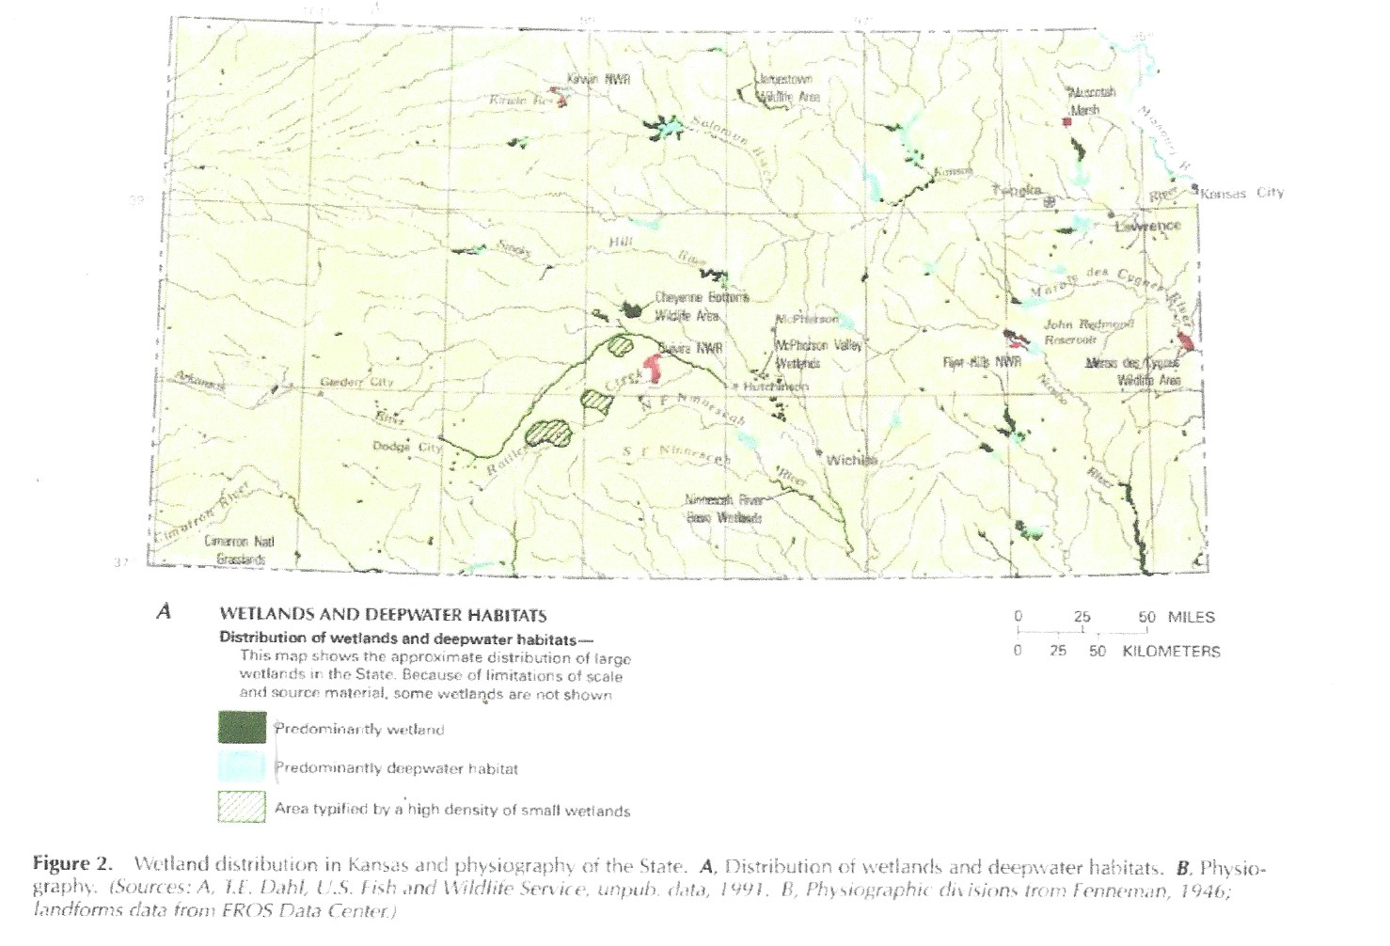The Department of Wildlife and Parks manages most of the 22,265 acres of State-owned wetlands in Kansas. The agency has acquired, by purchase or lease, additional acreage in the playa-lakes region and the McPherson Valley Wetlands through Federal funding from FWS and, as part of the five-State Playa Lakes Joint Venture, from the North American Waterfowl Management Plan (Kansas Department of Wildlife and Parks, 1992b). The North American Waterfowl Management Plan is a multinational program for restor­ing waterfowl breeding populations by habitat acquisition and en­hancement. Through its Wildlife Habitat Improvement Program, the Department of Wildlife and Parks provides financial and technical assistance to landowners who improve or develop wildlife habitat on private lands.