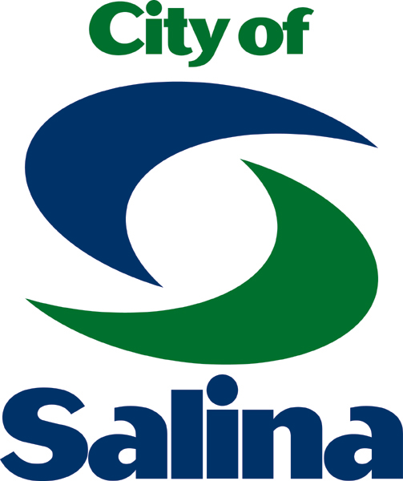
Lakewood Discovery Center
Salina Parks and Recreation Department

250 Lakewood Dr., Salina, KS 67401 • (785) 826-7335 • www.salina-ks.gov

Dear Potential ECO-MEET Participants,

Lakewood Discovery Center invites students from your school to join us for our annual Regional ECO-MEET, scheduled for Thursday, September 26, 2024. This event is a great opportunity for area students to participate in scholastic competition. The goal of ECO-MEET is to provide a competitive atmosphere that promotes education as well as interest in our natural environment. Lakewood is one of nine regional meets held in the state. Participants at regional meets compete for scholarship money and the chance to advance on to the state competition, held this year on Thursday November 7th.
Students compete in teams of three or four, as well as individually. For a history of ECO-MEET as well as additional information about this event, please refer to the Kansas ECO-MEET website.

The Lakewood ECO-MEET is open to the first 20 teams to register and pay their registration fees of $10 per participant. Space is on a first come, first serve basis. Coaches may bring up to 4 teams per school. Coaches need not supply us with team rosters initially. We must know, however, the number of teams each school plans to bring. Please email your team’s interest to brian.underwood@salina.org. the deadline to enter is September 20th.

The Lakewood Regional ECO-MEET covers schools from an eight county area, including Saline, Ellsworth, Ottawa, Dickinson, Chase, Marion, McPherson, and Cloud counties. For more information about ECO-MEET consult your fact sheet or visit www.kansasecomeet.org/. If you have any questions or concerns, feel free to contact us at Lakewood Discovery Center.

We hope to hear from you soon!

Thank you,

Brian Underwood
Director of Natural Resources
Lakewood Discovery Center
City of Salina
Salina, KS 67401
785-826-7335
brian.underwood@salina.org

