Kansas ECO-Meet
24th Annual

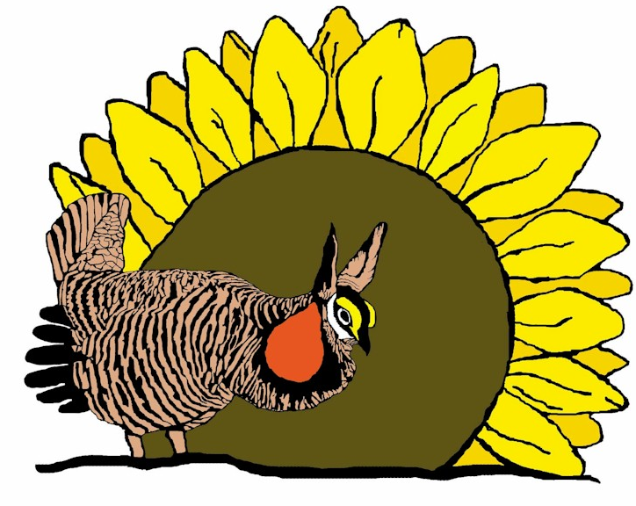

November 7th, 2024
Webster Conference Center
Salina, Kansas

2024 State ECO-Meet

Mission Statement…
“To challenge and inspire an interest in, appreciation of and an understanding of the natural sciences and the Kansas environment thru interscholastic competition.”

Vital Statistics…
When is the 2024 State ECO-Meet?
Thursday, November 7th. The event will take place rain or shine! All events,
except the Scavenger Hunt, will be conducted in an enclosed structure.

Where is the State ECO-Meet being held?
At the Webster Conference Center For maps, information,
and travel directions go to: Map & Directions – Webster Conference Center (webstercc.org):

What time does the State ECO-Meet begin?
Promptly at 9:00 am. Please plan on arriving between 8:00 am and 8:45 am to
Check-in and for team pictures. If your school is late, teams and individuals will
less time for their first scheduled event, which begins at 9:15 am.

Where do schools and individuals park?
Parking is in front of the main multipurpose and gymnasium building.

Where do the competitors check-in?
The check-in station is located at the Conference Center lobby (see map). Campus Map – Webster Conference Center (webstercc.org)
Everyone may enjoy the morning refreshments beginning at 8:00 am.

What are the fees for the ECO-Meet?
A registration fee of $15.00/competitor/coach will be collected at check-in.
NOTE: Please make checks payable to Kansas ECO-Meet. Credit cards are not accepted. The registration form can be mailed to:
Ellen Rader
Wilson State Park
#3 State Park Rd
Sylvan Grove, KS 67481

Or emailed to: ellen.rader@ks.gov
If emailing registrations, please bring payment to the event or make arrangements for late payment if necessary.

Will lunch be provided?
Yes, lunch will be provided to all competitors, coaches, drivers (that have either paid in advance or at registration). Meal tickets will be issued to all paid participants, coaches and drivers. Non-participants (including coaches, parents,
drivers, etc. that have not paid in advance or at registration) can find a variety of eating establishments south on Ohio St or on 9th St. If you have special dietary requirements, please contact Camp Webster directly.

How should you dress?
The State ECO-Meet will be held regardless of the weather, so please dress
appropriately.

Can we stay at the Webster Conference Center?
Overnight housing may be available on a limited basis. Arrangements to stay at the facility must be made by each school, as the ECO-Meet committee is not involved with that aspect of the competition. If you are interested in staying on-site, please visit: Webster Conference Center – a place for everyone (webstercc.org)

What are other places to stay the night before the meet”
Salina has a good number and variety of motels available.

More questions?
For more information about Camp Webster, contact Sarah at (785) 827-6565 or. For more questions concerning the Kansas ECO-Meet competition, contact Mike Rader at (620) 672-0708 or e-mail: mike.rader@ks.gov

Remember…
- The first, second, and third place teams from each regional ECO-Meet as well as the first and second place individual winners in the Wetlands/Aquatic ecosystem test and the Mammalogy focus test are qualified to compete at the 2024 State ECO-Meet.
- Teams can only compete for team scholarships and individuals qualifying at their regional meet for State will only compete for scholarships in the areas in which they qualified.
- No substitutions of team members or individuals can be made from the regional meet. If a member of a qualifying team cannot attend, the team must compete with only the remaining team members.
- Teams will present their regional interpretive presentation. However, improvements are encouraged. Props and make-up may be used but you must be ready to present when called upon.
- Teams will give their interpretive event presentations in the order shown on the schedule.
- All other participants in the interpretive event are to act as the audience for other teams.
- Rules and regulations of the State ECO-Meet are subject to change. Any and all changes will be explained in advance to all teams and coaches. The ECO-Meet committee welcomes any suggestions or comments about the event and will consider any submitted ideas.
- After-meet packets will be emailed out to all coaches with their team and individual students’ results in the days following the event
- Professionals from various fields of interest will conduct the 2024 State Eco-Meet.
- All decisions by the judges are final.

About the awards…
- Scholarships, medals, and certificates will be presented to each member of the 1st, 2nd, and 3rd place overall teams. Scholarships are as follows: 1st place - $300; 2nd place - $200; 3rd place - $100.
- Scholarships, medals, and certificates will be presented to the 1st and 2nd place individual winners in the Wetlands/Aquatic ecosystem test and the Mammalogy focus test. Scholarships are as follows: 1st place - $200, 2nd place - $100.
- A traveling trophy will be awarded to the 1st place overall team winner. The trophy will reside at the team’s school until the 2025 State ECO-Meet.
State scholarship claim forms can be obtained at http://www.kansasecomeet.org

Get Online! Check out the latest information about the 2024 State ECO-Meet at: www.kansasecomeet.org

2024 Kansas State ECO-Meet Schedule of Events
When: November 7, 2024 (Thursday)
Where: Webster Conference Center (785) 827-6565

8:00 – 9:00 a.m. – Check-in at the main lobby
Morning refreshments provided
Photographs taken of all participants
9:00 – 9:10 a.m. – Welcome and last-minute guidance
9:15 – 10:15 a.m. – Event #1
10:25 – 11:25 a.m. – Event #2
11:35 – 12:20 p.m. – Lunch
12:30 – 1:30 p.m. – Event #3
1:35 – 2:35 p.m. – Event #4
ASAP – Presentation of Awards
Photographs taken of all winners
3:00 p.m. - Departure

The 2024 Kansas State ECO-Meet is Sponsored by:

Kansas Wildscape Foundation
KDWP Wildlife Education Service
Chickadee Checkoff
Visit Salina
Barton Community College
Friends of Great Plains Nature Center
Friends of Milford Nature Center
The Kansas Native Plant Society
Safari Club International – Kansas City Chapter

